**Installation Procedure Microsoft Dynamics NAV 2017 RoleTailored Client**

1. Download the Microsoft Dynamics NAV 2017 Product DVD from the following location:

Carya File Server (Internal)  
\\10.33.75.15\files\NAV Client\  
Username: download

Password: 2870Carya

Carya File Server (External)   
<https://files.carya.cloud/NAV%20Client/>  
Username: download

Password: 2870Carya

1. Extract the downloaded Zip file to folder c:\Temp\
2. Click setup.exe in the root folder:  
     
   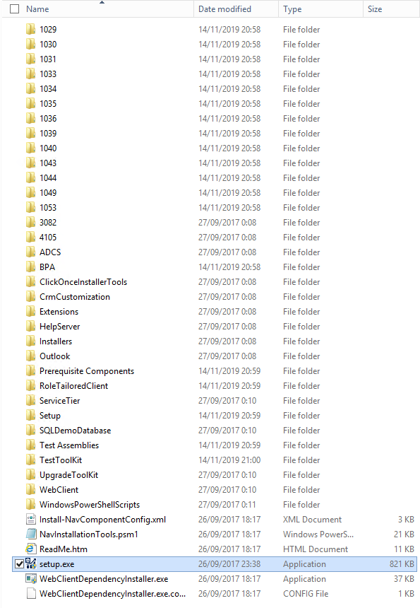
3. Click the Next button:  
     
   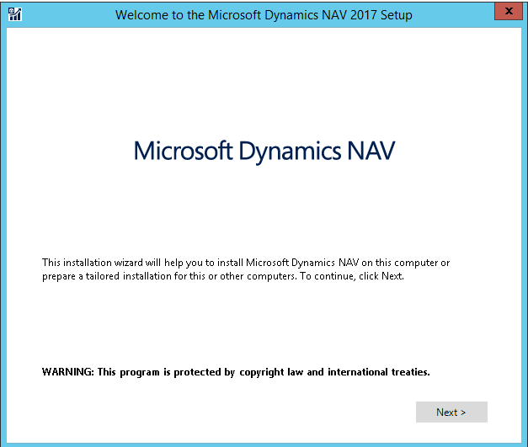
4. Click the “I accept” button:  
     
   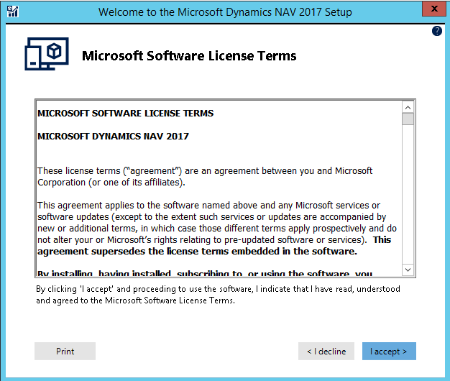
5. Click Choose an Installation option:  
     
   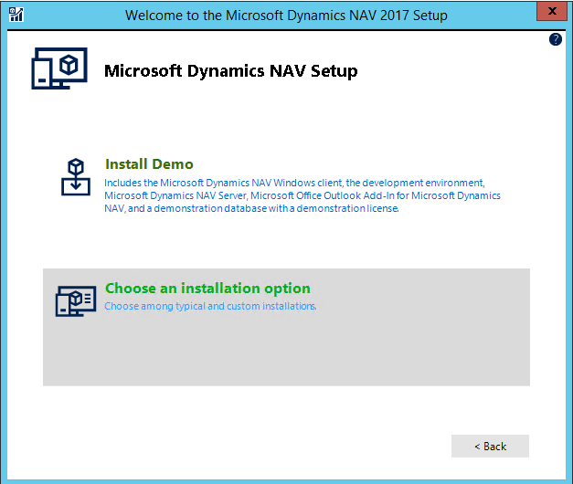
6. Choose option Custom:  
     
   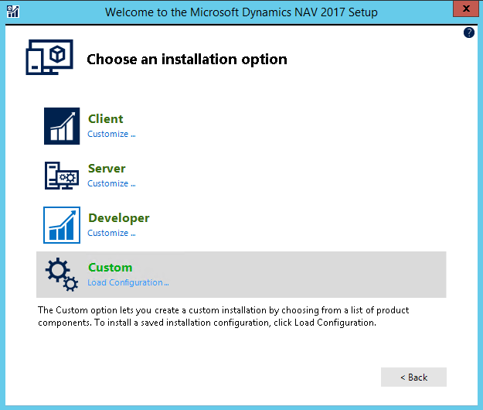
7. Only select the Client option with option Microsoft Office Excel Add-in. Make sure no other options are selected and click the Next button:  
     
   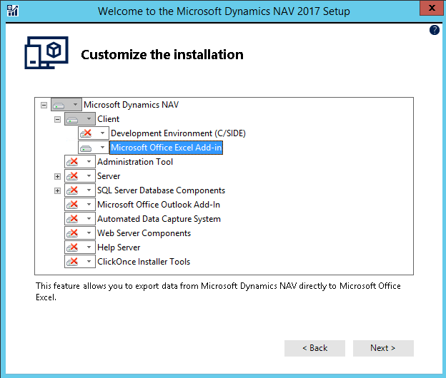
8. In the Specify parameters screen, only change parameter Server Name from localhost to the name of the NST Server (e.g. CARYANST030009) and click the Apply button. Do not change any of the other parameters:  
     
   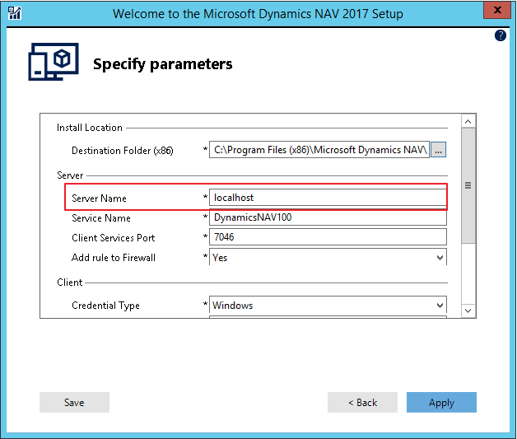
9. The Dynamics NAV 2017 RoleTailored Client is now installed. The following screen appears. Wait until the installation is finished:  
     
   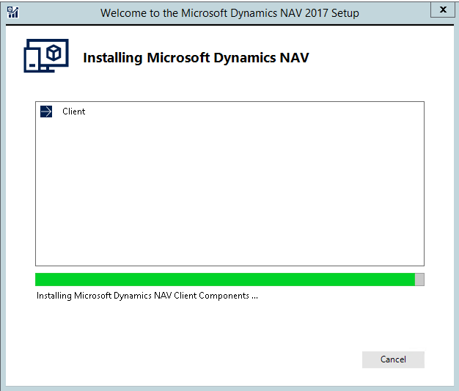
10. When the installation has completed successfully, the following screen is shown:  
      
    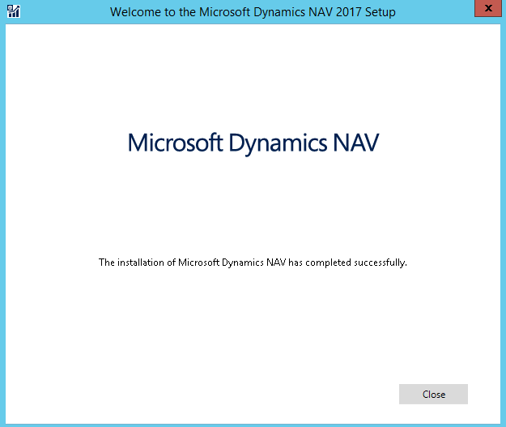  
      
    When Warnings or Errors are listed, the installation has NOT completed successfully and the installation is rolled-back automatically. In that case, first fix the listed problem and start the installation procedure again.
11. Download the .NET Components for incadea.dms from the following location:

Carya File Server (Internal)  
\\10.33.75.15\files\NAV Client\  
Username: download

Password: 2870Carya

Carya File Server (External)   
<https://files.carya.cloud/NAV%20Client/>  
Username: download

Password: 2870Carya

.NET Components to be installed on EACH client:

* Add-ins
* NAV Communication

.NET Components to be installed only for customers using the old Service Scheduler:

* Dispatch Board
* Service Scheduler
* Presence Board

The Time Clock must ONLY be installed on machines where users will perform clockings (atelier)

For customers using the new Web Service Planner NO additional components need to be installed (only Add-ins and NAV Communication)  
  
The new Web Service Planner is ONLY accessible through Google Chrome. The Web Service Planner does NOT support Internet Explorer/Microsoft Edge.

1. Download the Carya add-ins for incadea dms from the following location:  
     
   Carya File Server (Internal)

\\10.33.75.15\files\NAV Client\

Username: download

Password: 2870Carya

Carya File Server (External)

<https://files.carya.cloud/NAV%20Client/>

Username: download

Password: 2870Carya

Extract the downloaded ZIP file to folder C:\Program Files (x86)\Microsoft Dynamics NAV\100\RoleTailored Client\Add-ins\

